**HOMEWORK ASSIGNMENTS – ZCCA TRAINING**

**ASSIGNMENT – 1**

**APPLICATION NAME : CONTACT MANAGEMENT**

**FORMS REQUIRED : 1. COMPANY FORM**

**2. CONTACT FORM**

**Create the forms with the help of the screen shots placed below**

**COMPANY FORM**

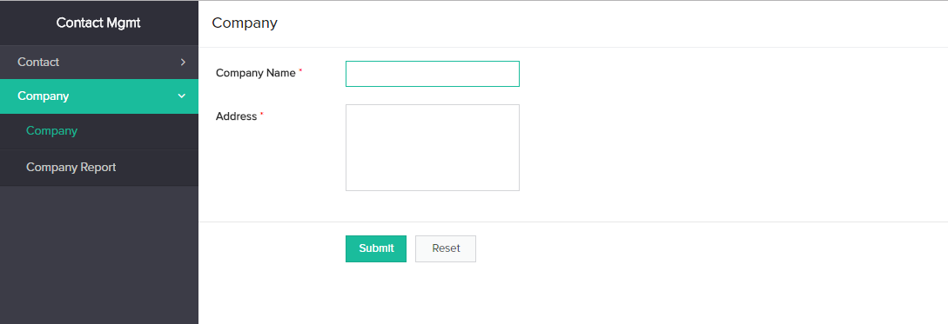

**CONTACT FORM**

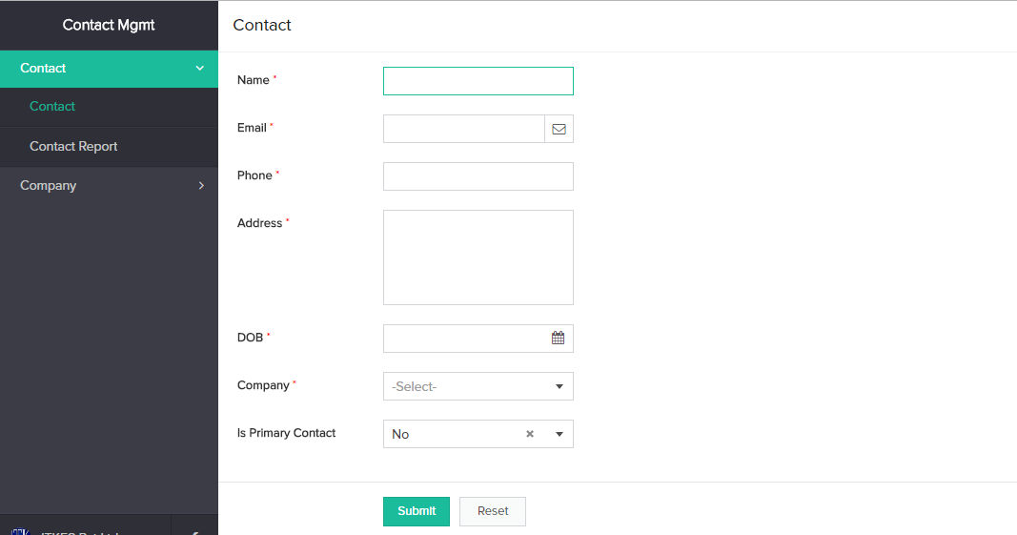

**TASKS TO BE DONE :**

1. From **company form** take company name field and make it as a lookup in **contact form**
2. During on submission of **contact form** the below mentioned criteria should be satisfied, write code for the same.

Criteria: Say, if 10 entry happens for the contact form where 3 entries under one company name and 7 entries under another company name. If you have 7 entries under the same company name, in that only one contact should be marked as ‘yes’ for is_primary_contact field. Make sure one contact should be a primary contact and only one should be a primary contact for the group of the contacts under the same company. **Note: Primary contact means important contact from the company**

**ASSIGNMENT – 2**

**APPLICATION NAME : ORDER MANAGEMENT**

**FORMS REQUIRED : 1. PRODUCT FORM**

**2. ORDER ITEM FORM**

**3. ORDER FORM**

**Create the forms with the help of the screen shots placed below**

**PRODUCT FORM**

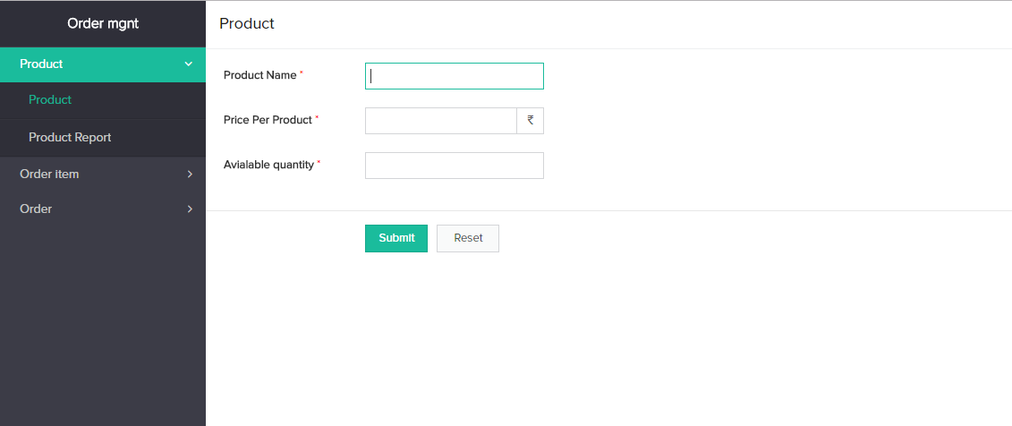

**ORDER ITEM FORM**

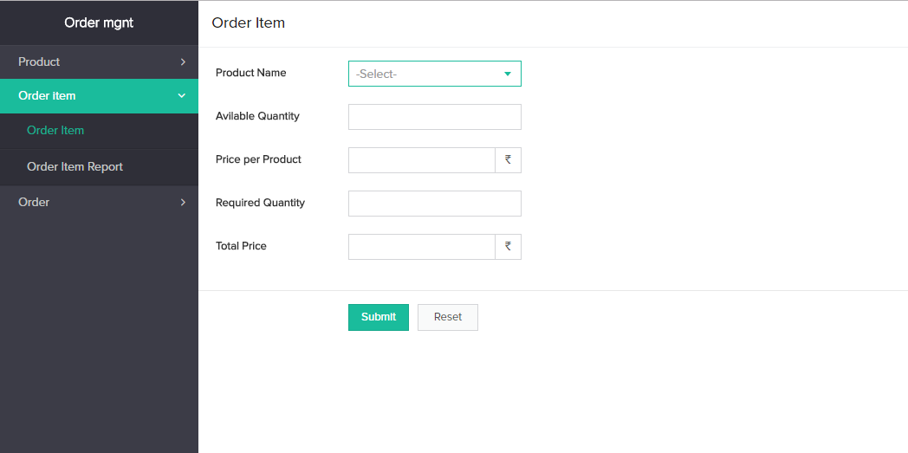

**ORDER FORM**

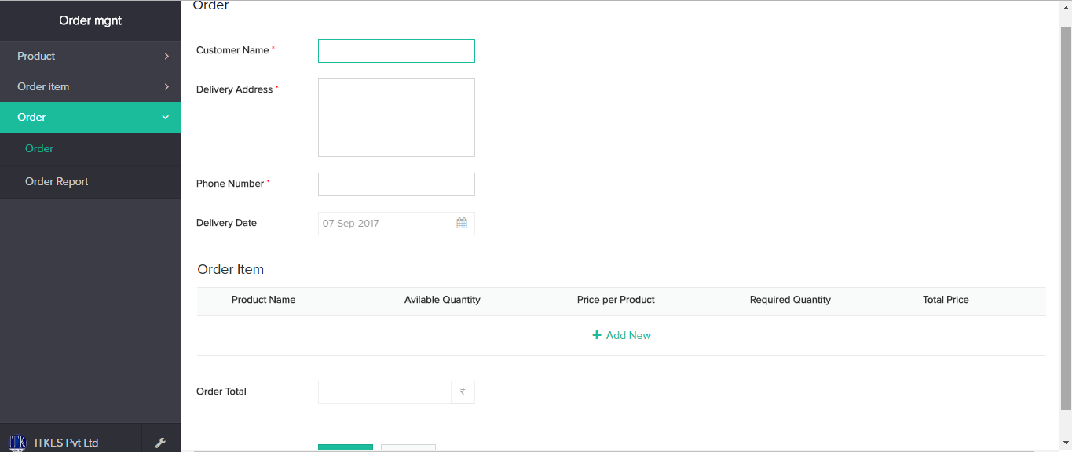

**TASKS TO BE DONE :**

1. Product Name field from **Product form** should be a lookup field in order item form
2. Add Order item form as a subform field in order form
3. Do calculation for the below mentioned cases
   1. By selecting product name in order form, availability and priceperproduct of the selected product should be displayed
   2. Total price should be calculated for each product
   3. On submission of **Order form,** availability in **Product form** should be updated.
   4. Sum of total price of products in the subform should be displayed in order total.
   5. During onload of **Order form**, date of delivery should be currentdate+3 days eg.current date is 1st sep then date of delivery should be 4th sep.

**ASSIGNMENT – 3**

**APPLICATION NAME : EVENT MANAGEMENT**

**FORMS REQUIRED : 1. ADD NEW EVENT CATEGORY FORM**

**2. ADD NEW VENUE FORM**

**3. CREATE NEW EVENT FORM**

**4. CUSTOMER DETAILS FORM**

**5. BOOK EVENT FORM**

**Create the forms with the help of the screen shots placed below**

**ADD NEW EVENT CATEGORY FORM**

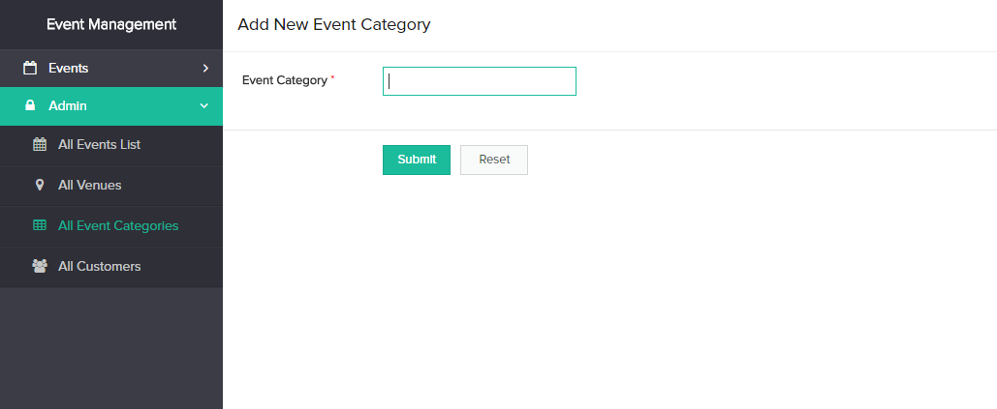

**ADD NEW VENUE FORM**

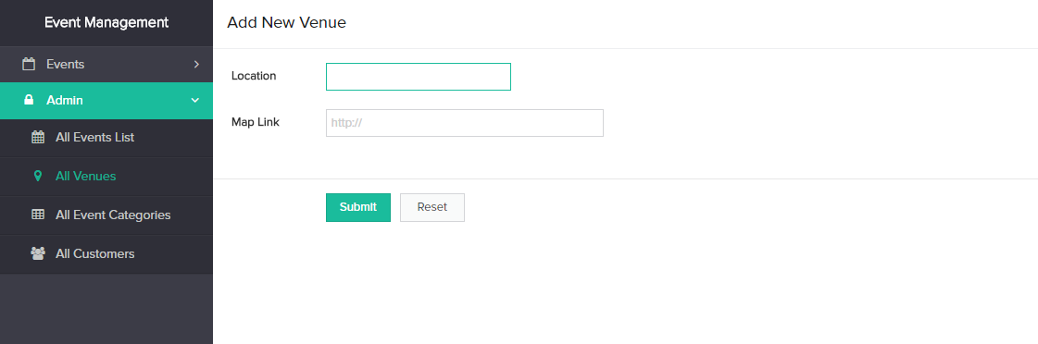

**CREATE NEW EVENT FORM**

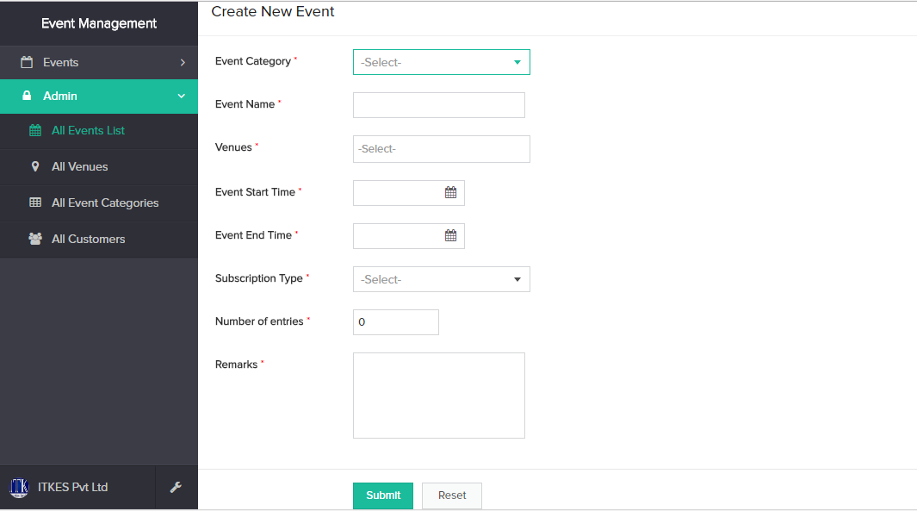

**CUSTOMER DETAILS FORM**

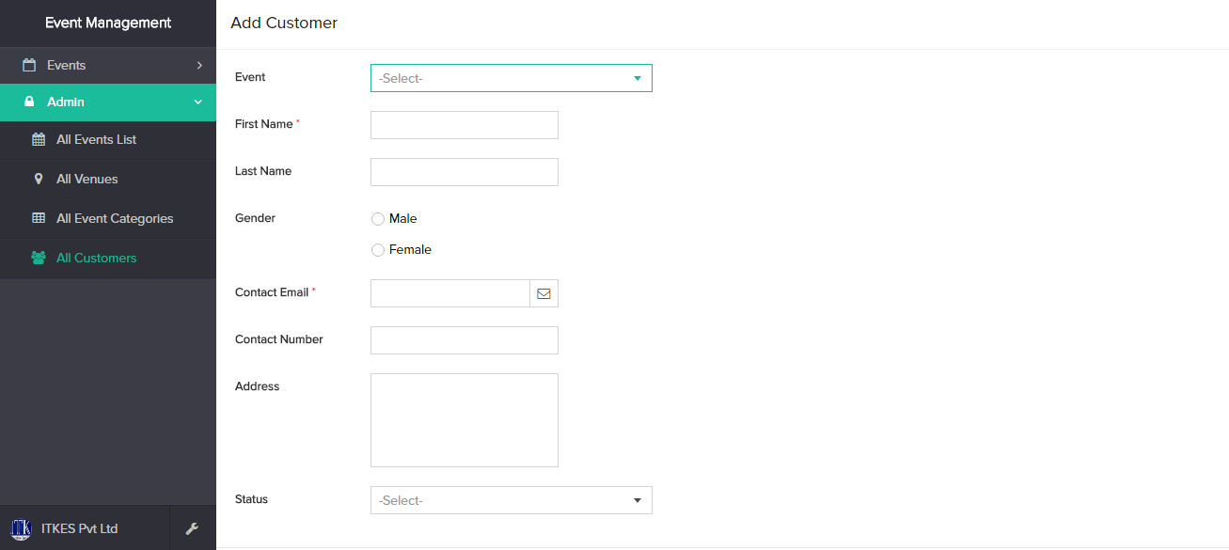

**BOOK EVENT FORM**

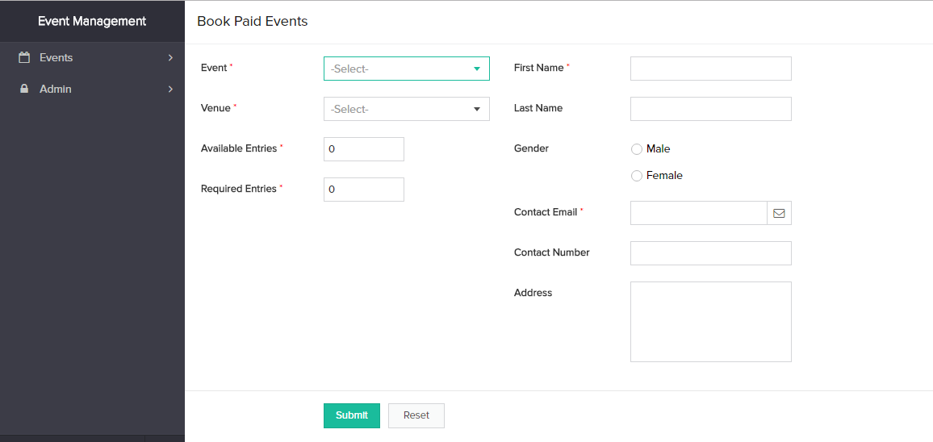

**TASKS TO BE DONE :**

1. Event category field from **add new event category form** and venue field form **add new venue form** is a lookup field in **create new event form**
2. Event Name field from **create new event form** and venue field form **add new venue form** is a lookup field in **Book Event form**
3. By selecting the event name in **Book Event form** available entries should be displayed automatically by fetching it from **create new event form →number of entries field**
4. On submission of **Book Event form,** number of entries in create new event form should be updated.
5. On submission of **Book Event form,** customer details should be updated in customer form
6. On submission of **Book Event form,** email should be sent to the customer stating their purchase of ticket with event details

**ASSIGNMENT – 4 – (i)**

**APPLICATION NAME : LEAVE APPLICATION**

**FORMS REQUIRED : 1. EMPLOYEE FORM**

**2. LEAVE FORM**

**Create the forms with the help of the screen shots placed below**

**EMPLOYEE FORM**

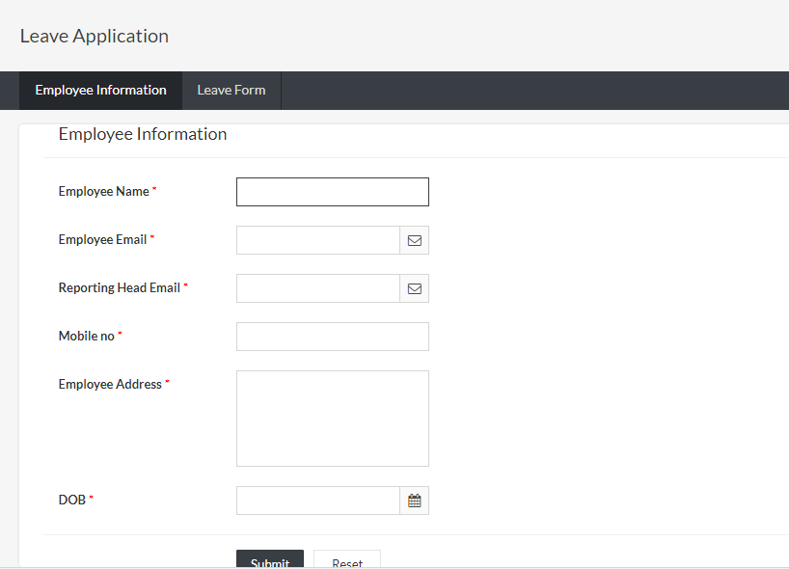

**LEAVE FORM**

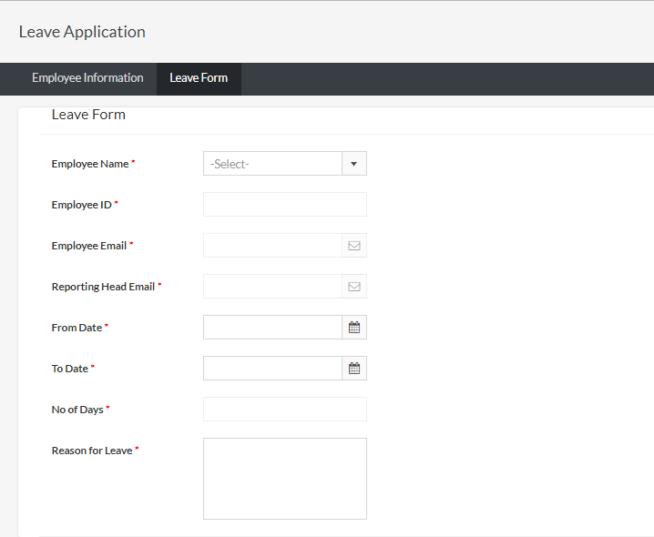

**TASK TO BE DONE:**

1. Employee name from **employee form** is a lookup field in leave form
2. By selecting the employee name in lookup field of **leave form** all other details employee details fields (employee id, employee email, reporting head email) should be filled up automatically
3. By selecting From and To date No. of days should be calculated
4. If No. of days is greater than 2 , then alert should shown stating that. You cannot apply for more than 2 days at a time
5. Add 2 custom buttons 1) Approve and 2) Reject in the leave form report, which helps the manager to approve of reject the leave of the employee

**ASSIGNMENT – 4 – (ii)**

**APPLICATION NAME : LEAVE APPLICATION**

**FORMS REQUIRED : 1. EMPLOYEE FORM**

**TASK TO BE DONE:**

1. Employee should get the “Happy birthday wishes” every year as a mail in their inbox.

Hint: Use DOB field from employee form